**4. Git Conflicts**

1. Move to project folder

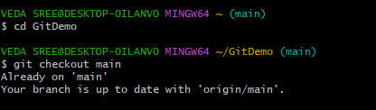

1. Create a branch **“GitWork”.** Add a file “hello.xml”.

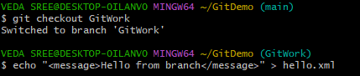

1. Update the content of “hello.xml” and observe the status

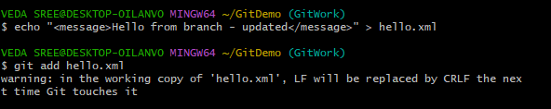

1. Commit the changes to reflect in the branch and switch to master

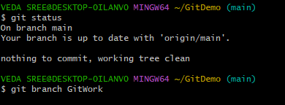

1. Add a file **“hello.xml”** to the master and add some different content than previous and commit the changes to master

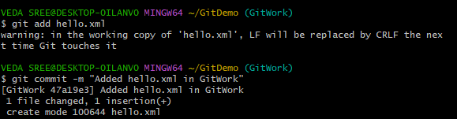

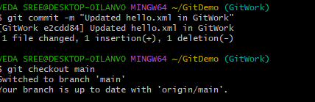

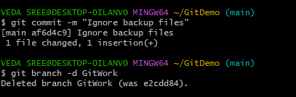

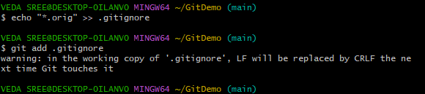 

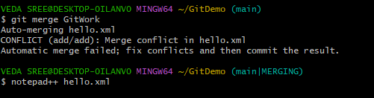

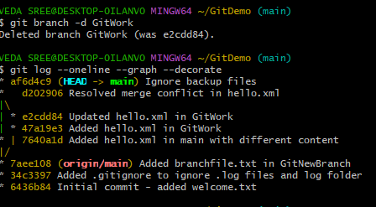

1. Commit the changes to the master, once done with conflict



1. Observe the git status and add backup file to the .gitignore file.

Commit the changes to the .gitignore

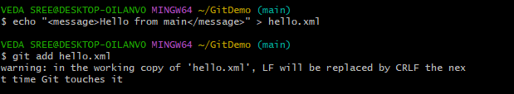

1. List out all the available branches
2. Delete the branch, which merge to master.
3. Observe the log by executing **“git log –oneline –graph –decorate”**

